CHAPTER-I
INTRODUCTION TO SENSORS AND MEASUREMENT

Definition of Sensor:
A sensor is a device that detects a physical change in its surroundings and converts it into a measurable or usable signal, usually electrical.

Difference between Sensor, Transducer, and Transmitter
Sensor
- Detects a physical quantity (temperature, pressure, light, etc.)
- Gives a response to the change
- Example: Thermistor, LDR
Transducer
- Converts one form of energy into another
- Usually converts physical quantity into electrical signal
- Example: Microphone, Load cell
Transmitter
- Sends the measured signal to another place
- Converts signal into standard form (like 4–20 mA)
- Example: Temperature transmitter

Range in Electrical Measurement:
Range is the span between the minimum and maximum values of an electrical quantity that a measuring instrument can measure accurately.
Example:
If an ammeter measures current from 0 A to 10 A, its range is 0–10 A.
Range = minimum value to maximum value measurable by an instrument.
Response time is the time taken by a measuring instrument or system to react to a change in the measured quantity and reach a specified percentage of its final steady value.

Accuracy
Accuracy is the degree to which a measured value is close to the true or actual value.

Precision
Precision is the ability of an instrument to give the same reading repeatedly for the same measurement.

Sensitivity
Sensitivity is the ability of an instrument to detect small changes in the measured quantity.

Dead Band
Dead band is the range of input values for which there is no change in the output of the instrument.

Dead Time
Dead time is the time delay between a change in input and the start of the instrument’s response.

Signal Transmission
Signal transmission is the process of sending a measured signal from one point to another for monitoring or control.

Pneumatic Signal

- A pneumatic signal is a signal transmitted using compressed air pressure to represent and control a measured quantity.

Hydraulic Signal

A hydraulic signal is a signal transmitted using pressurized liquid (usually oil) to represent a measured quantity.

Electronic Signal

An electronic signal is a signal transmitted using electrical quantities such as voltage or current to represent information.

Standard Signal Ranges
Standard signal ranges are fixed ranges used to transmit measurement signals accurately and uniformly.

1. Standard Current Signal
- 4–20 mA (most widely used)
- 0–20 mA

2. Standard Voltage Signal
- 0–10 V
- 1–5 V
- 0–5 V

3. Pneumatic Signal
- 3–15 psi (≈ 0.2–1.0 bar)

4. Digital Signal
- 0 and 1 (ON/OFF)
- Logic levels like TTL, CMOS

Electronic Transmitter

An electronic transmitter is a device that converts a sensor output into a standard electrical signal (such as 4–20 mA or 0–10 V) for transmission.

Pneumatic Transmitter

A pneumatic transmitter is a device that converts a measured quantity into a standard air-pressure signal (usually 3–15 psi) for transmission.

Smart Transmitter

A smart transmitter is a microprocessor-based transmitter that provides digital communication, self-diagnostics, and easy calibration along with standard output signals.

CHAPTER-II
PRINCIPLES OF VARIOUS SENSORS

Classification of Sensors
Sensors can be classified in several ways based on their working principle and output:

1. Based on Power Requirement
- Active Sensors – Require external power
Example: RTD, Strain gauge
- Passive Sensors – Generate their own signal
Example: Thermocouple, Piezoelectric sensor

2. Based on Output Signal
- Analog Sensors – Give continuous output
Example: LDR, Potentiometer
- Digital Sensors – Give discrete (ON/OFF) output
Example: Proximity sensor

3. Based on Contact
- Contact Sensors – Require physical contact
Example: Limit switch
- Non-Contact Sensors – No physical contact
Example: Infrared sensor

4. Based on Measured Quantity
- Temperature Sensors – RTD, Thermistor
- Pressure Sensors – Bourdon tube, Piezo sensor
- Position Sensors – LVDT, Encoder
- Flow Sensors – Orifice meter, Turbine meter

5. Based on Transduction Principle
- Resistive – Strain gauge
- Capacitive – Level sensor
- Inductive – LVDT
- Piezoelectric – Vibration sensor

Characteristics of Sensors
Sensor characteristics describe how a sensor behaves and performs.

1. Static Characteristics
- Accuracy – Closeness to true value
- Precision – Repeatability of readings
- Sensitivity – Output change per unit input
- Linearity – Straight-line relationship between input and output
- Range – Minimum to maximum measurable value
- Resolution – Smallest detectable change
- Hysteresis – Different outputs for same input (increasing/decreasing)
- Dead Band – No output change for certain input range

2. Dynamic Characteristics
- Response Time – Time to reach final value
- Dead Time – Delay before output starts
- Time Constant – Speed of response
- Stability – Ability to maintain output over time

Calibration of Sensors
Calibration is the process of comparing the sensor output with a standard reference and adjusting it to ensure accuracy.

Calibration of Different Sensors

1. Temperature Sensors
- Thermocouple: Calibrated using ice point and boiling point
- RTD: Calibrated using standard temperature baths

2. Pressure Sensors
- Bourdon Tube: Calibrated using a dead-weight tester
- Strain Gauge Pressure Sensor: Compared with standard pressure source

3. Displacement Sensors
- LVDT: Calibrated using precise linear movement
- Potentiometer: Compared with known displacement

4. Flow Sensors
- Orifice Meter: Calibrated using volumetric flow method
- Turbine Flow Meter: Compared with standard flow reference

Steps in Calibration
- Apply known standard input
- Measure sensor output
- Compare with true value
- Adjust sensor if required
- Repeat for full range

Importance of Calibration
- Improves accuracy
- Reduces measurement error
- Ensures reliable readings

1. Displacement Sensors – Working Principle
Displacement sensors measure the linear movement or change in position of an object.
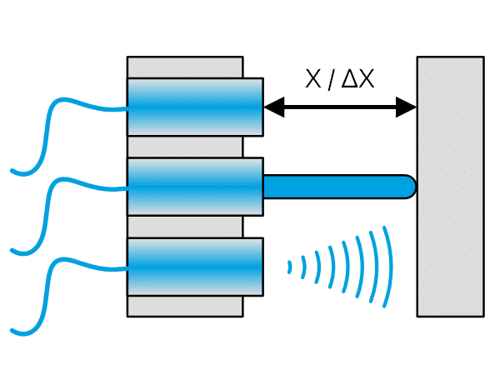

Working Principle:
They work by converting mechanical displacement into an electrical signal. When the object moves, a physical parameter such as resistance, inductance, or capacitance changes, which is then converted into an electrical output.
Examples:
- LVDT – Change in induced voltage due to core movement
- Potentiometer – Change in resistance with displacement

2. Position Sensors –
It is a sensor that is used to detect the object’s movement & convert it into signals which are suitable for transmission, control, or processing.
These sensors are normally used for measuring the distance of the body from the reference position.
So it detects how far the body has moved from one position to another and this output is frequently used as feedback to the control system to take appropriate action.
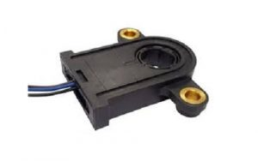Position Sensor
The position sensor working mainly depends on providing motion control, counting & encoding different tasks through determining the existence or nonexistence of a target or otherwise by detecting its speed, direction, distance, or motion.

Position Sensor Circuit Diagram & Working
A common type of position sensor that is used to monitor rotary or linear motion is known as a potentiometer. It is a voltage divider that provides a changeable DC voltage reading for the computer. These types of sensors are normally used to determine the position of the air conditioning unit door, a valve, a seat track, etc. A potentiometer sensor circuit is used to measure the sum of voltage drop to find out the position.
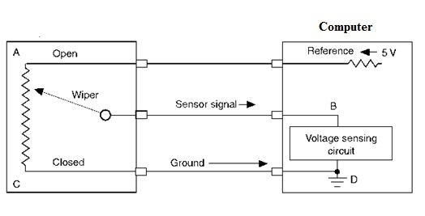Potentiometer Position Sensor Circuit
Generally, the potentiometer includes a wire wound resistor including a movable wiper in the center. A stable voltage value like 5 volts is given to the ‘A’ terminal. If the wiper is connected close to the ‘A’ terminal, then the voltage drop will be low, which is denoted through a high voltage signal back to the computer throughout the ‘B’ terminal. When the wiper moves in the direction of the ‘С’ terminal, then the sensor voltage signal toward the ‘В’ terminal will be decreased.
Here, the computer interprets various voltage values into various shaft positions. Once the wiper moves across the resistor, then the unit position can be tracked through the computer. Since voltage applied must flow throughout the whole resistance, then temperature & other factors do not make incorrect & false sensor signals toward the computer. A rheostat is not precise & its use is limited within computer systems.

Advantages
The advantages of position sensors include the following.
- Potentiometric sensors are Inexpensive & high accurate.
- LVDT or RVDT sensors provide high accuracy & Heavy-duty and are less sensitive to harsh environments.
- Optical sensors are highly accurate and have high resolution.
- Magnetic & Hall effect sensors are less sensitive to liquid and heavy-duty.
- The magnetostrictive sensor is accurate especially for long lengths and heavy-duty.

Disadvantages
The disadvantages of position sensors include the following.
- Potentiometric sensors are sensitive to dust, extreme temperatures, high wear & tear.
- LVDT or RVDT is expensive, heavy & bulky.
- Optical type sensors are sensitive to dust, temperatures, and delicate.
- Magnetic & Hall effect sensors are responsive to impact, interrupted through electrical wires, magnetic materials & Hysteresis.
- Magnetostrictive type sensors are sensitive to changes in temperature, lack of accuracy for small lengths & expensive
Applications
The applications of position sensors include the following.
- These sensors are essential devices to measure rotary or linear positions.
- These sensors are used where measurement of movement is required.
- These sensors are used in different industries like Automotive, Hydraulics, Motorsport, medical, Mobile Vehicle, Aerospace, etc.
- Some of the other applications mainly include medical equipment, packaging machines, Drive-by-wire cars, Fly-by-wire aircraft systems, Injection molding machines, etc.

3. Motion Sensors
- A motion sensor is an electronic device specifically designed to detect physical movement within a defined area and convert that movement into an electrical signal.
- The motion sensor device operates by sensing variations in its environment, whether through changes in heat signatures, reflected sound waves, or The beauty of a motion detection sensor lies in its ability to trigger automated responses without human intervention.
- The beauty of a motion detection sensor lies in its ability to trigger automated responses without human intervention.

Working principle
The working principle of motion sensor technology can be categorized into two main approaches: active detection and passive detection.
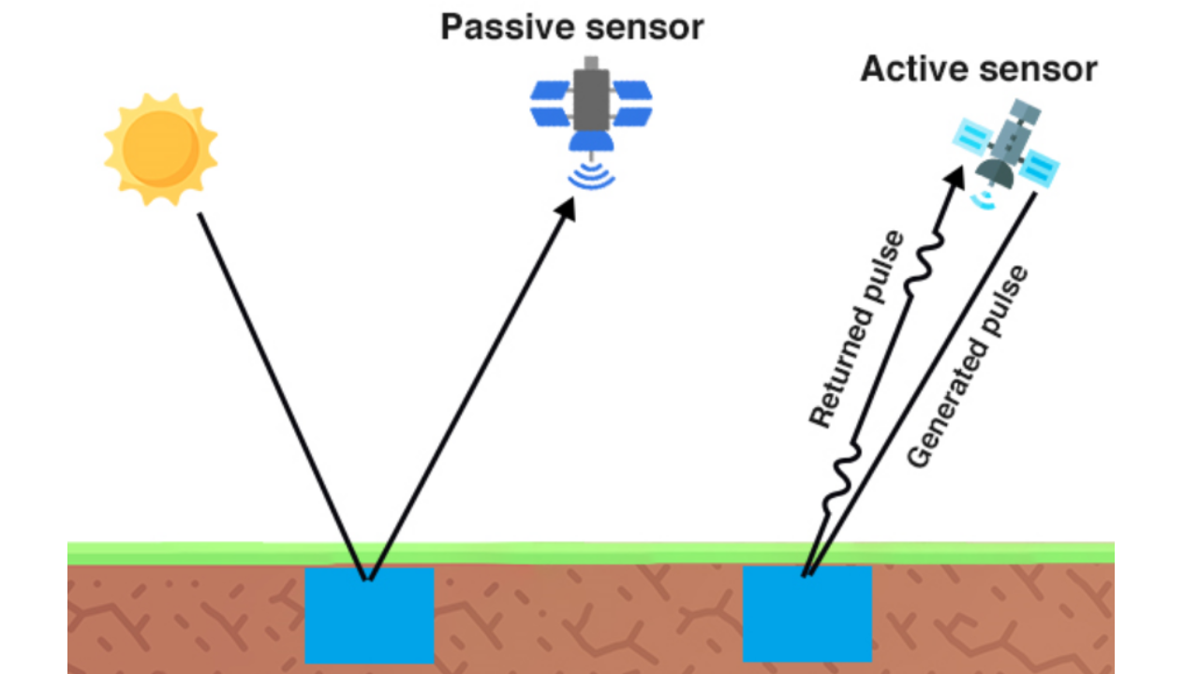

Passive Detection:
Passive sensors, particularly Passive Infrared (PIR) sensors, are the most common type of motion detector in consumer applications. These sensors work by detecting changes in infrared radiation emitted by warm objects, primarily humans and animals.
Every living being emits infrared radiation as heat, and PIR sensors are specifically designed to detect variations in this thermal signature.
- The sensor contains pyroelectric materials that generate an electrical charge when exposed to infrared radiation
- Two sensing elements are positioned side by side, creating a differential detection system
- When a warm body moves across the sensor's field of view, it first activates one sensing element, then the other
- This differential change generates a positive and negative electrical pulse, which the sensor interprets as motion
- A Fresnel lens covering the sensor divides the detection area into multiple zones, increasing sensitivity

Active Detection:
Active sensors take a different approach by emitting energy and measuring the reflections that return. These systems include both a transmitter and a receiver, working together to detect disturbances in the emitted signal.
- Ultrasonic sensors emit high-frequency sound waves beyond human hearing range (typically 25-40 kHz)
- The sound waves bounce off objects and return to the sensor
- By measuring the time it takes for echoes to return, the sensor calculates distance and detects movement
- Microwave sensors emit electromagnetic waves and analyze the frequency shift of reflected signals (Doppler effect)
- When an object moves toward or away from the sensor, the frequency of reflected waves changes, indicating motion
The motion detector sensor processes these signals through integrated circuits that amplify and filter the detection signal, eliminating false triggers from minor environmental changes.
Most modern sensors incorporate adjustable sensitivity controls and time delays to optimize performance for specific applications.
Motion Sensor detect various physical phenomena depending on their type and design. Understanding what these sensors can and cannot detect helps in selecting the right sensor for specific applications.

Heat Signatures:

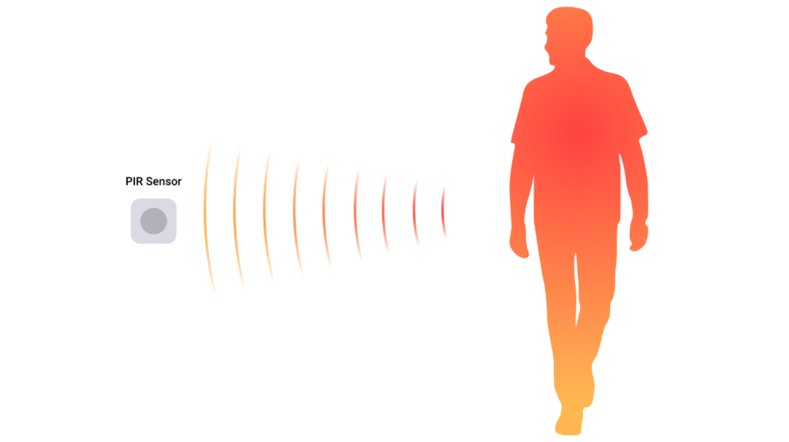

Passive infrared sensors primarily detect infrared radiation emitted by warm bodies. They are particularly effective at sensing humans and animals because of their body heat, typically detecting movement within a temperature range of 20-40°C.
These sensors excel at identifying the heat contrast between a moving warm object and the cooler background environment.

Movement and Position Changes:
All motion sensors fundamentally detect changes in position rather than absolute position. They respond to dynamic changes in their monitored area, whether it's a person walking, a door opening, or an object being moved.
The speed of movement can also affect detection, with most sensors having optimal sensitivity ranges for human walking speeds.

Distance and Proximity:
Ultrasonic and microwave sensors excel at measuring distance changes. They can determine not only that something has moved but also how far away it is and in what direction it's moving. This capability makes them valuable for applications requiring precise spatial awareness.

Environmental Disturbances:
Advanced motion sensors can detect subtle environmental changes such as air pressure variations, acoustic signatures, and electromagnetic field disturbances.
Some dual-technology sensors combine multiple detection methods to reduce false alarms and increase accuracy.

Limit Switch
- A limit switch is an electromechanical device operated by a physical force applied to it by an object.
- Limit switches are used to detect the presence or absence of an object.
- These switches were originally used to define the limit of travel of an object, and as a result, they were named Limit Switch.
For example, a roller limit switch can be used to detect an object moving past a specific point on a conveyor belt.
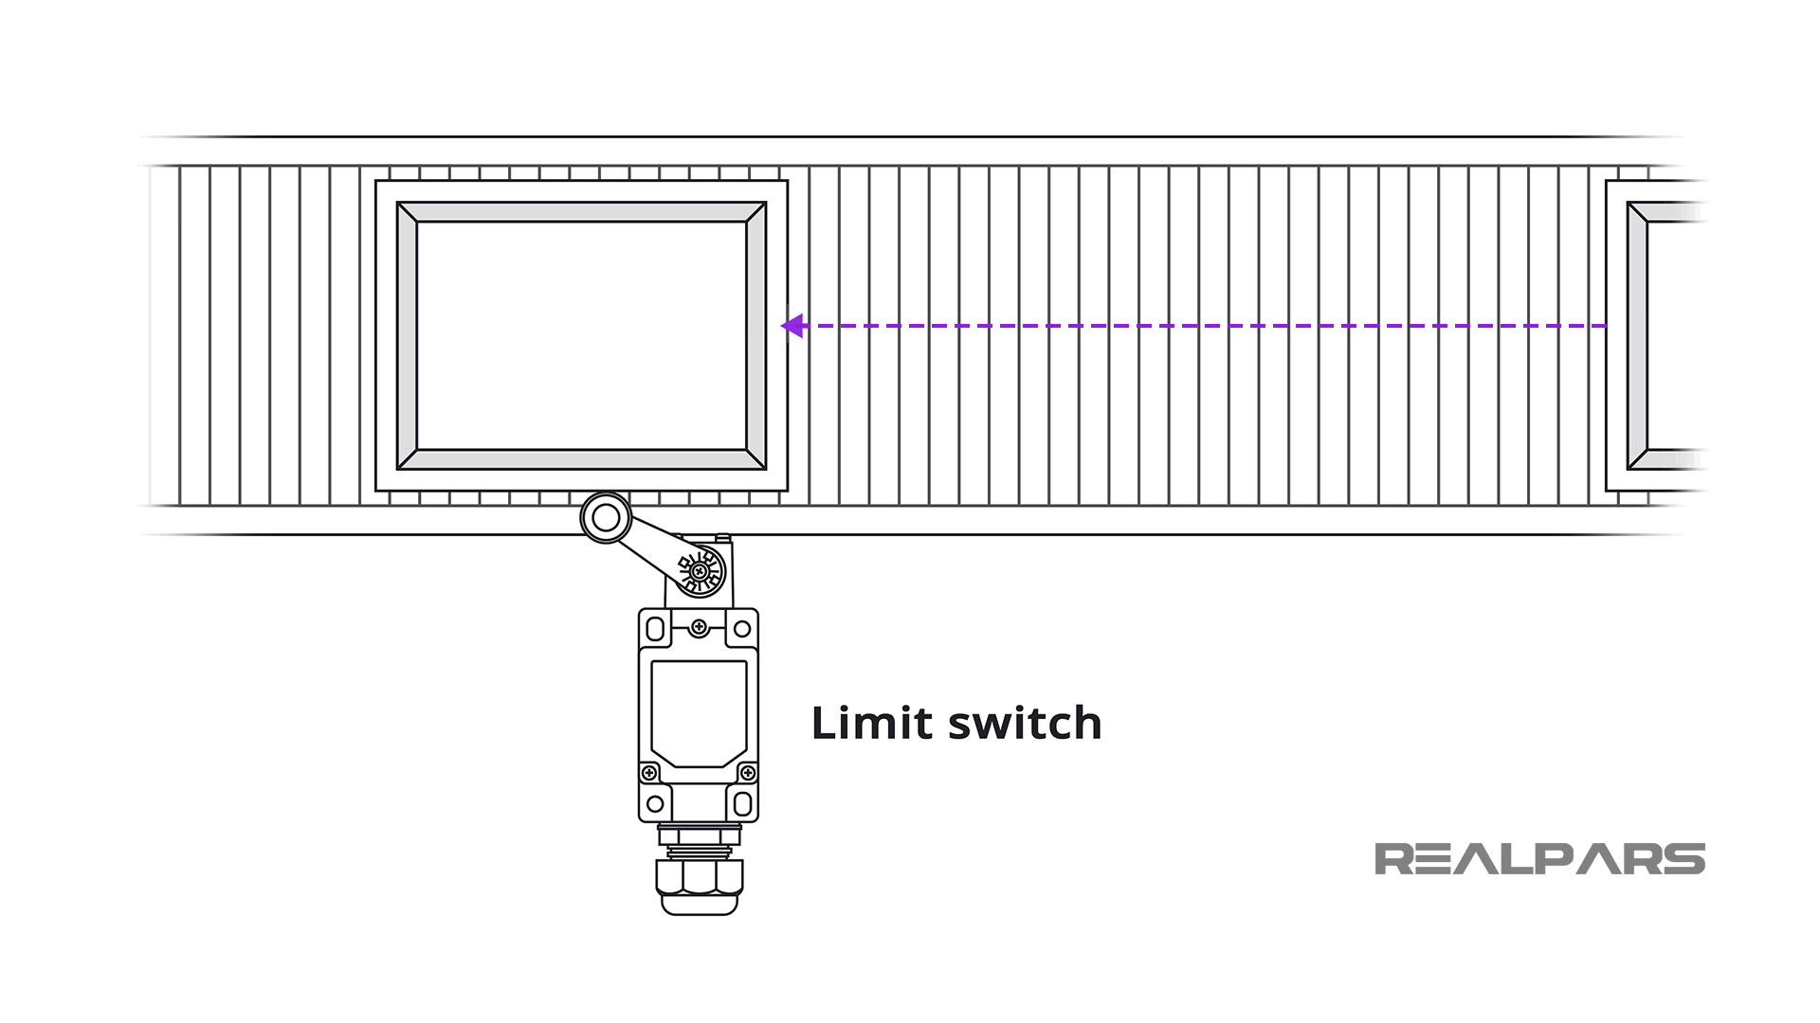
Working Principle
- A limit switch detects an object's physical movement or presence, typically using a mechanical actuator such as a lever or plunger.
- Limit switches are electromechanical devices consisting of an actuator mechanically linked to an electrical switch.
- When an object contacts the actuator, the switch will operate causing an electrical connection to make or break.
- This change signals that a component or part has reached a predefined point or position.
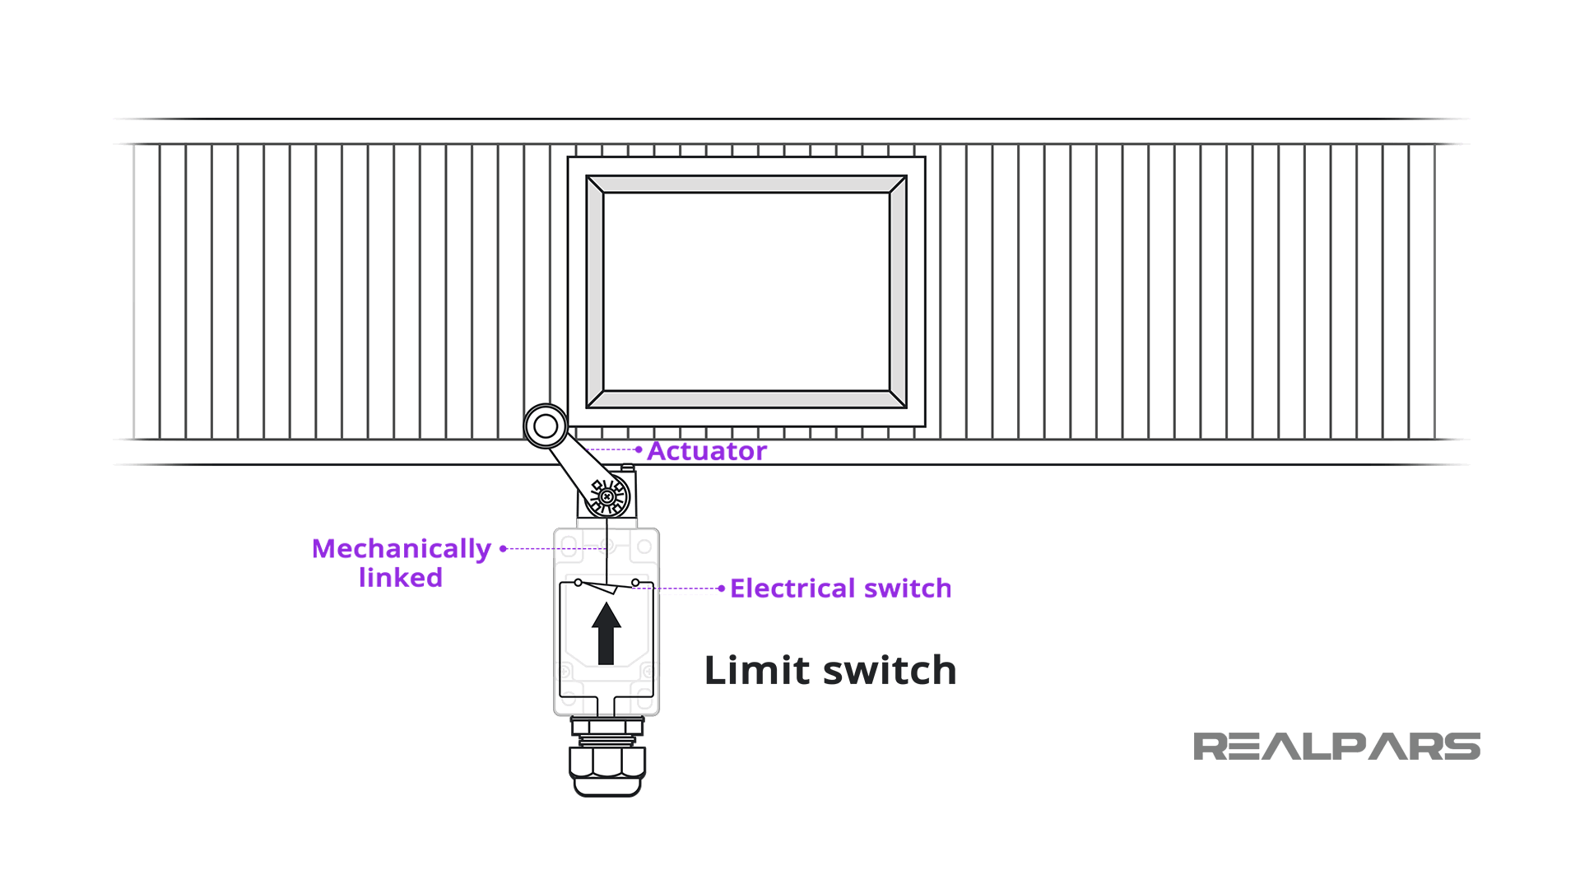

Configurations of limit switches
Electrical Limit switches are available in several switch configurations: Normally Open, Normally Closed, or one of each.
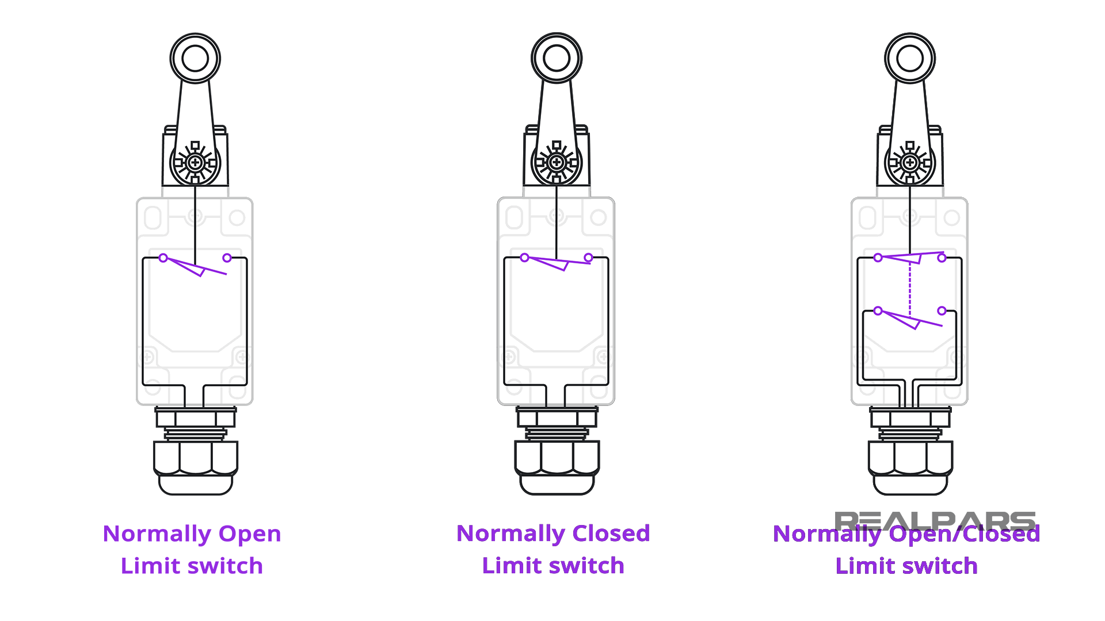

Symbols of limit switches
Depending on the origin of the electrical schematic, you may see limit switches drawn in different ways.
The International Electrotechnical Commission (IEC) and the National Electrical Manufacturers Association (NEMA) have slightly different symbols.
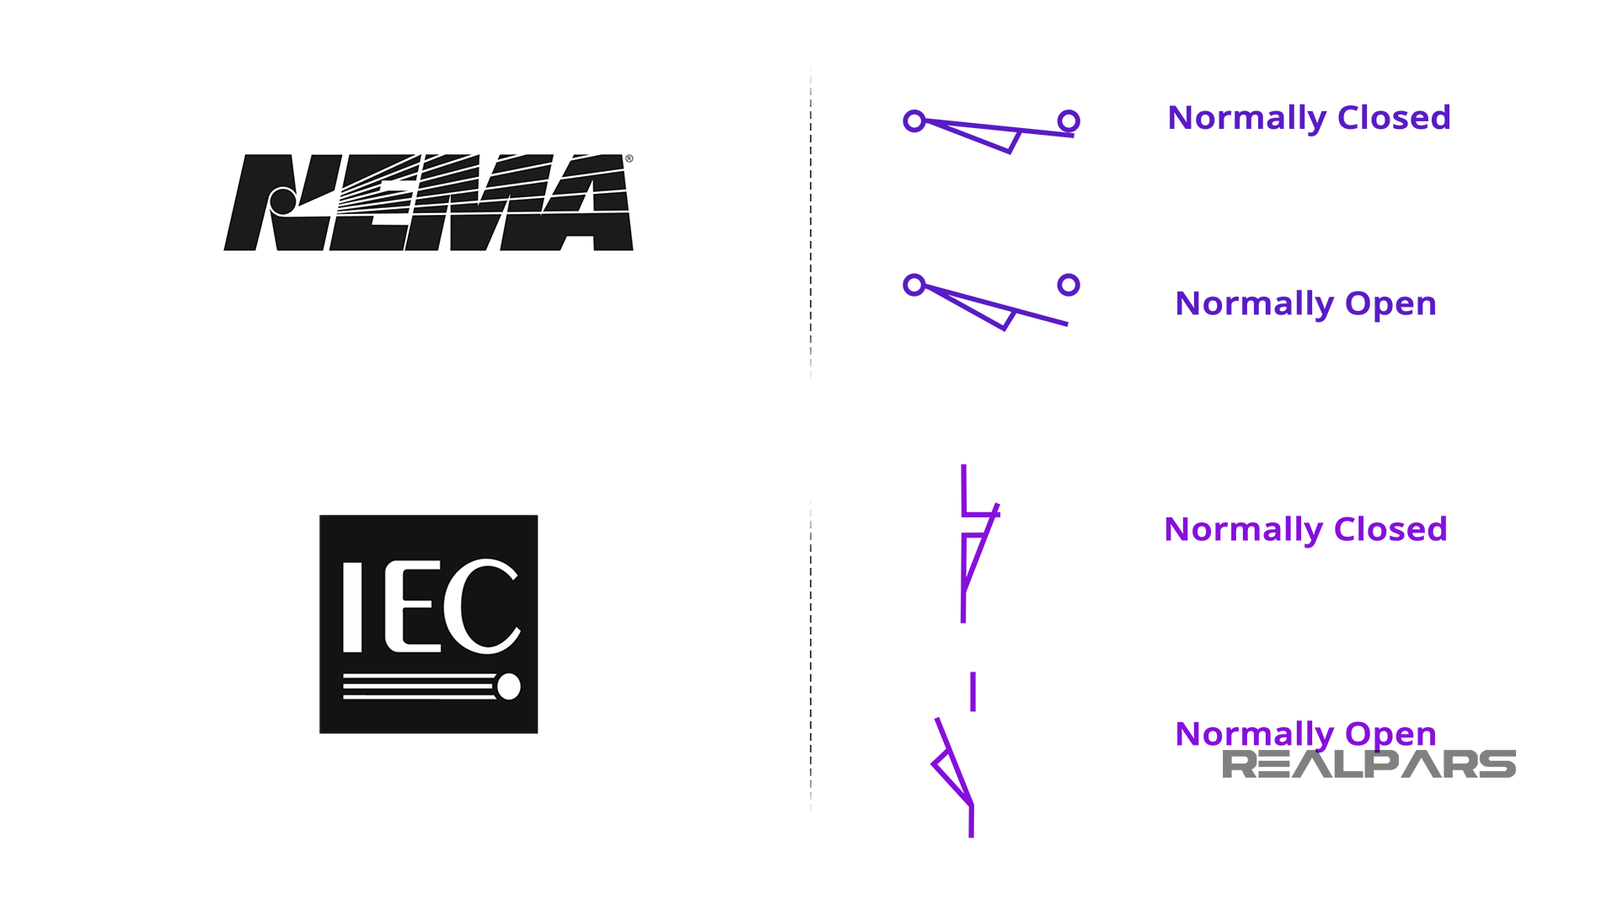

Microswitch
A microswitch has 2 limit switches operating together and sharing a common terminal. One limit switch is normally open and the other is normally closed.
To be technically correct, the switch configuration is Single Pole Double Throw, or commonly referred to as SPDT.
The dashed line indicates that both switches are mechanically connected and will operate at the same time.
Be aware that not all micro switches are configured as a SPDT Limit Switch. Some are configured as a Single Pole Single Throw (SPST) limit switch, which has only two terminals.
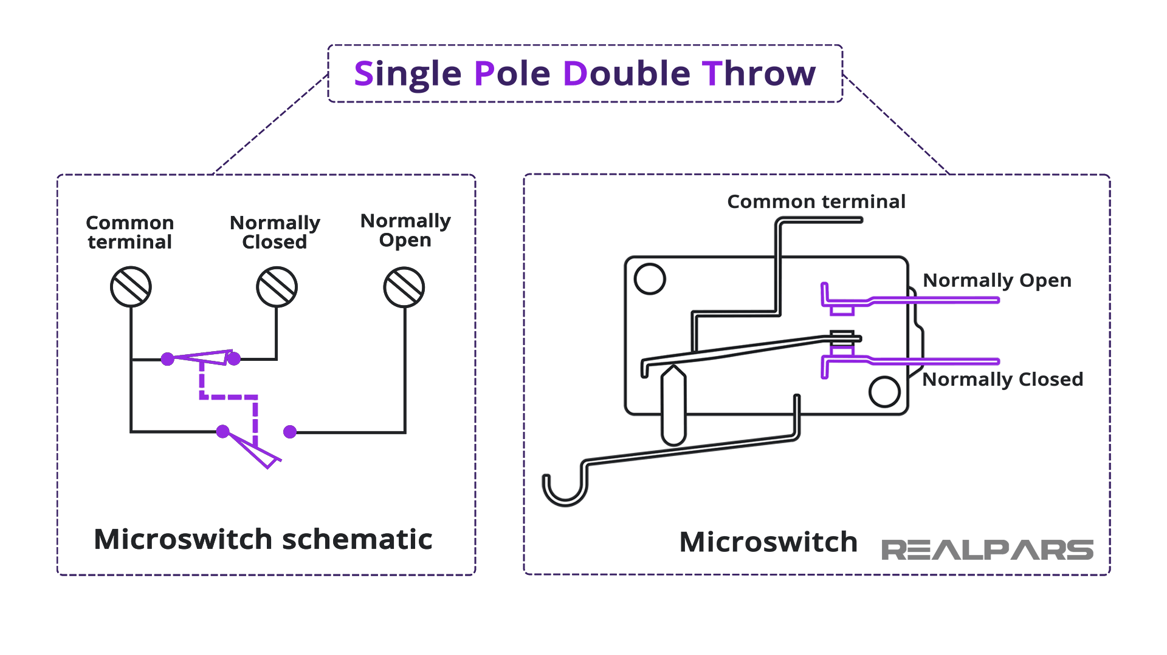

Limit switches applications
When you open the fridge door, a light comes on inside. A limit switch is used to detect if the fridge door is open or closed.

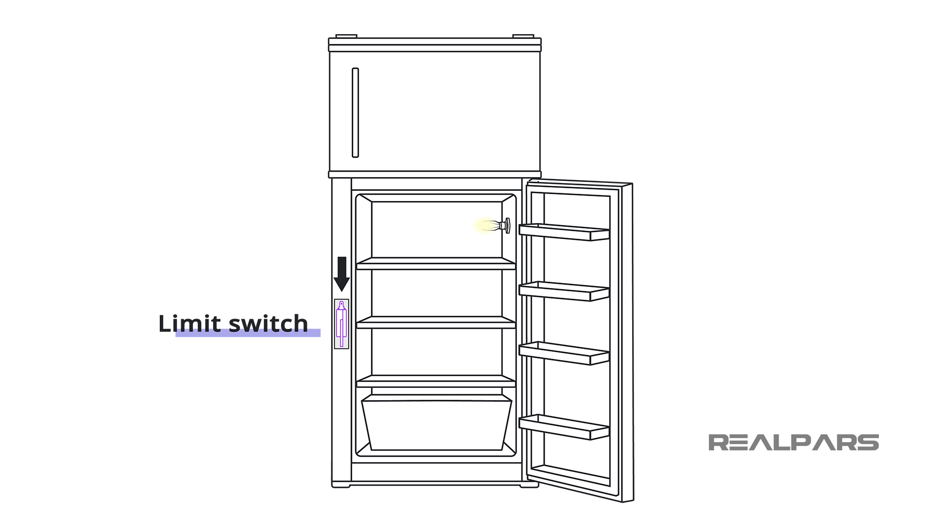

Proximity Sensor
The proximity sensor is a non-contact sensor that can detect an object/person (target) without any physical contact when the target enters the sensor’s field of range. Depending on the sensor used, the proximity sensor working principle can be based on infrared, ultrasonic, light, electric properties, etc.
There are many types of proximity sensors and each identifies a target in distinctive ways.

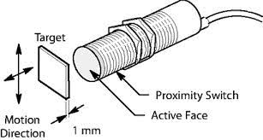

These sensors are extremely useful in applications where an object or target is to be detected in a certain space - to create alerts, or execute a chain of other automations like turning on the lights and fans when a person enters the room.
Working Principle:-
Proximity sensors come in different varieties and forms, each more suitable than the rest in certain scenarios. Below are the list of commonly found proximity sensors one could use and the working of proximity sensor.

Inductive Proximity Sensors Working
An inductive proximity sensor working principle is to detect metallic objects. This is because the sensor utilized the magnetic field to detect the presence of objects. When a metal object enters the field, the inductive properties between the sensor and the metal get altered thereby detecting the presence of the object. Depending on the type of metal and how inductive it can get, the sensor can either detect it from a greater distance or a shorter distance.

Inductive Proximity sensors are useful in situations where the object it is designed to detect is a known metallic object with a particular inductive properties
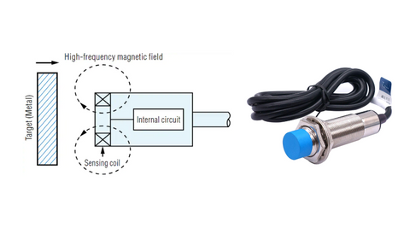

Capacitive Proximity Sensors Working
Capacitive proximity sensor working principle is measure distance based on the changing capacitance between the sensor and the target. Therefore, the object it detects will not be limited to metallic targets and will work on any target capable of carrying an electrical charge.
Capacitive type sensors are primarily used for liquid detection
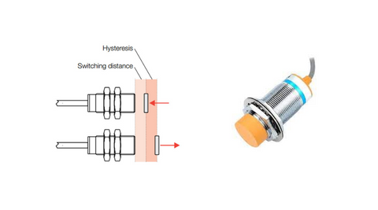

IR-based Proximity Sensors Working
IR proximity sensor working principle is applying a voltage to an IR LED, which emits infrared light. The light then hits the target, bounced back and the photodiode will detect the intensity of the reflected light. Based on the threshold settings of the sensor, the proximity sensor can determine if a target is close to the sensor and accordingly give a signal.
IR-type proximity sensors are relatively inexpensive and are suitable for hobby-grade projects requiring simple target detection capability
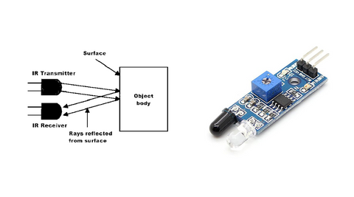

Ultrasonic Proximity Sensors Working
Ultrasonic proximity sensor working principle is emitting sound frequencies greater than the audible limit of human hearing. They are mainly used for measuring distance but can also be easily used as a proximity sensor. The basic principle of the ultrasonic IR proximity sensor is similar to that of IR. The ultrasonic proximity sensor emits an ultrasonic pulse and receives a pulse back. Based on the time difference between sending the pulse and receiving the pulse, the ultrasonic sensor can determine the distance between the sensor and the target object. Based on the set condition, the ultrasonic sensor can output logic high or low.

Because ultrasonic sensors are based on sound and not electricity or electromagnetic waves, they can be used in situations where the former types of sensors would have trouble, like reflective surfaces, clear plastics, etc.
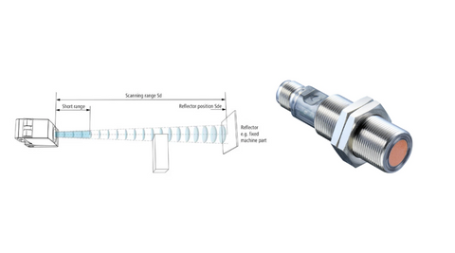

Linear Variable Differential Transformer(LVDT)
- The LVDT full form is “Linear Variable Differential Transformer” is LVDT. Generally, LVDT is a normal type of transducer.
- The main function of this is to convert the rectangular movement of an object to the equivalent electrical signal.
- LVDT is used to calculate displacement and works on the transformer principle.
- The LVDT sensor diagram comprises a core as well as a coil assembly. Here, the core is protected by the thing whose location is being calculated, while the coil assembly is increased to a stationary structure.
- The coil assembly includes three wire-wound coils on the hollow shape. The inside coil is the major, which is energized by an AC source. The magnetic flux generated by the main is attached to the two minor coils, making an AC voltage in every coil.
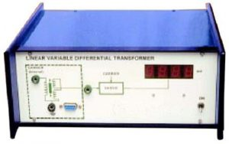Linear Variable Differential Transformer
The main benefit of this transducer, when compared with other LVDT types, is toughness. As there is no material contact across the sensing component.
Because the machine depends on the combination of magnetic flux, this transducer can have an unlimited resolution. So the minimum fraction of progress can be noticed by an appropriate signal conditioning tool, and the transducer’s resolution is exclusively determined by the declaration of the DAS (data acquisition system).

Construction
LVDT comprises a cylindrical former, which is bounded by one main winding in the hub of the former and the two minor LVDT windings are wound on the surfaces. The amount of twists in both the minor windings is equivalent, but they are reversed to each other like clockwise direction and anti-clockwise direction.
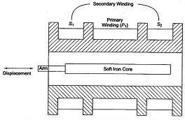Linear Variable Differential Transformer Construction
For this reason, the o/p voltages will be the variation in voltages among the two minor coils. These two coils are denoted with S1 & S2. Esteem iron core is located in the middle of the cylindrical former. The excitation voltage of AC is 5-12V and the operating frequency is given by 50 to 400 HZ.

Working Principle of LVDT
The working principle of the linear variable differential transformer or LVDT working theory is mutual induction. The dislocation is nonelectrical energy that is changed into electrical energy. And, how the energy is altered is discussed in detail in the working of an LVDT.
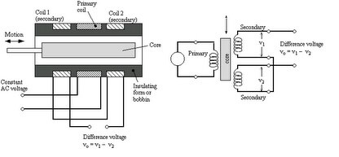LVDT Working Principle

Working of an LVDT
The working of the LVDT circuit diagram can be divided into three cases based on the position of the iron core in the insulated former.
- In Case-1: When the core of the LVDT is at the null location, then both the minor windings flux will equal, so the induced e.m.f is similar in the windings. So for no dislocation, the output value (e_{out}) is zero because both the e1 & e2 are equivalent. Thus, it illustrates that no dislocation took place.
- In Case-2: When the core of the LVDT is shifted up to the null point. In this case, the flux involving minor winding S1 is additional as contrasted to flux connecting with the S 2 winding. Due to this reason, e1 will be added as that of e2. Due to this e_{out} (output voltage) is positive.
- In Case-3: When the core of the LVDT is shifted down to the null point, In this case, the amount of e2 will be added as that of e1. Due to this e_{out} output voltage will be negative plus it illustrates the o/p to down on the location point.
Output of LVDT
- The output of the measuring device like LVDT or linear variable differential transformer is a sine wave through amplitude that is proportional to off-center location & 0⁰ otherwise 180⁰ of phase based on the located side of the core.
- Here, full-wave rectification is used to demodulate the signal. The highest value of the engine out (EOUT) happens at the highest core displacement from the middle position.
- It is an amplitude function of the main side excitation voltage as well as the sensitivity factor of the specific type of LVDT. In general, it is quite considerable at RMS.
Strain gauge
A strain gauge is one of the imperative devices used in the field of geotechnical engineering to measure strain on diverse structures. By applying an external force, there would be a change in resistance of a strain gauge.
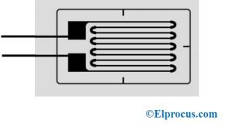strain-gauge
Construction:-

The basic construction of a gauge has an insulating flexible backing to support a metallic foil structure. This metallic coil is glued to a thin backing called a carrier, and the entire setup is fixed to an object using a suitable adhesive. As the object is deformed due to force, pressure, weight, tension, etc., the electrical resistance of foil changes. A Wheatstone bridge measures the change in resistivity, which is related to strain through a quantity known as Gauge Factor.
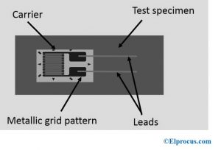strain-gauge-specimen-diagram
The small changes in resistance of a gauge are measured using the concept of Wheatstone bridge. The figure below illustrates the general Wheatstone bridge, which has four resistive arms and an excitation voltage, V_{EX}.
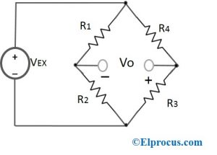Wheatstone-bridge
The Wheatstone bridge has two parallel voltage divider circuits. R1 and R2 form a one voltage divider circuit, R3 and R4 form second voltage divider circuit. The output voltage VO is given by:
Vo=[R3/(R3+R4 )-R2/(R1+2)]* V_{EX}
If R1/R2 = R4/R3, then the output voltage is zero and the bridge is said to be a balanced bridge.
A small change in resistance leads to a nonzero output voltage. If ‘R4’ is replaced with a strain gauge and any changes in the resistance of strain gauge will unbalance the bridge and produce nonzero voltage.

Gauge Factor of Strain Gauge
The gauge factor GF is given as
GF= (∆R⁄RG )/∈
Where,
‘ΔR’ is the change in resistance due to strain
‘RG’ is the resistance of the undeformed gauge
‘ε’ is the strain
The gauge factor of common metallic foils is around 2. The output sensor voltage SV of a Wheatstone bridge is given by,
SV=EV (GF.∈)/4
Where EV is the bridge excitation voltage

Strain Gauge Working
The functioning of a strain gauge entirely depends on the electrical resistivity of an object/conductor. When an object gets stretched within its limits of elasticity and does not break or buckle permanently, it becomes thinner and longer, resulting in high electrical resistance. If an object is compressed and does not deform, but, broadens and shortens, results in decreased electrical resistance. The values obtained after measuring the electrical resistance of a gauge helps to understand the amount of stress-induced.
The excitation voltage is applied at the input terminals of a gauge network, while the output is read at the output terminals. Normally, these are connected to a load and are likely to remain stable for longer periods, sometimes decades. The glue used for gauges depends on the duration of a measurement system – cyanoacrylate glue is suitable for short term measurements and epoxy glue for long term measurements.

Strain Gauge Working Principle
As we know that the resistance is directly dependent on the length and cross-sectional area of a conductor, which is given by R = L/A
Where,
‘R’= Resistance
‘L’ = Length
‘A’ = cross-sectional area
Clearly, the length of a conductor is altered with the change in size and shape of a conductor, eventually, altering the cross-sectional area and resistance.
Any normal gauge has a conductive strip that is long and thin, placed in a zig-zag fashion of parallel lines. The purpose of this zig-zag alignment is to elaborate on the small amount of stress that occurs between the parallel lines with much accuracy. Stress is defined as the resisting force of an object.

Strain Gauges Rosettes
Two or more gauges positioned closely in a rosette-like structure to measure the number of components to evaluate precise strain on the surface are known as strain gauge rosettes. The illustration is shown in the figure below.
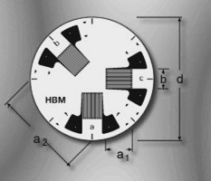strain-gauge-rosettes

Strain Gauge Load Cells
These load cells are most commonly found in industrial applications. It is highly precise and economical. Basically, a load cell consists of a metal body on which strain gauges are attached. For the metal body to be sturdy and less elastic, alloy steel, aluminum, or stainless steel are employed to design.
When an external force is applied on a load cell, the load cell is slightly deformed, and if not overloaded, it returns to its original shape.
If the load cell deforms, the gauge changes in shape, causing the change in electrical resistance of gauge, which in turn measures voltage.
There are common types of strain gauge load cells, which include bending beam, pancake, single point shear beam load cell, double-ended shear beam, wire rope clamps, and so on.

Characteristics of Strain Gauges
The important characteristics of strain gauges are:
- These are appropriate for longer periods with certain precautions
- They provide precise values with a change in temperature and other factors
- These are easy to manufacture because of simple components
- They are easy to maintain and has a long operating life
- This is totally encapsulated to protect from damages like handling and installation

Applications of Strain Gauge
The exceptional features enable these gauges to be used in the field of geotechnical engineering to monitor structures like dams, tunnels, etc. constantly and to avoid accidents well in advance. Some of the applications of strain gauges include –
- Rail monitoring
- Cable bridges
- Aerospace
- Nuclear power plants

Tachogenerator
A tachogenerator, also referred to as a tachometer generator or simply a tach generator, is a versatile rotary electromechanical device used to produce an electrical signal proportional to the shaft rotational speed
Tachogenerators are true speed measuring devices that rely on the basic principle of a generator to determine the speed of a rotating part based on voltage.
A tachogenerator is attached to the object whose speed is being measured — such as a fan or motor shaft — and evaluates the voltage of the power produced by the generator to determine the rotational speed of the object.
Tachogenerators are designed to ensure that the relationship between voltage and speed is extremely precise and linear within a specified range.

V_{o} = output voltage (V)
K_{t} = tachogenerator constant (V-s/rad)
ω_{s} = angular speed (rad/s)

Φ = flux per pole (Weber)
P = number of poles
Z = number of conductors in armature windings
a = number of parallel paths in armature windings
- Most tachogenerators used today are brushed DC types with a permanent magnet stator and a wound, rotating armature.
- One end of the armature is attached to the object whose speed is being measured, and the armature rotates within the magnetic field of the stator.
- As the measured object rotates, the rotation of the tachogenerator armature induces a voltage, and the amplitude of the voltage is proportional to the speed of rotation.
- A commutator converts the alternating current generated by rotation into direct current that can be interpreted by a voltmeter circuit and converted to speed.
- If the direction of rotation changes, the voltage polarity changes, so DC tachogenerators can determine both speed and direction of rotation.
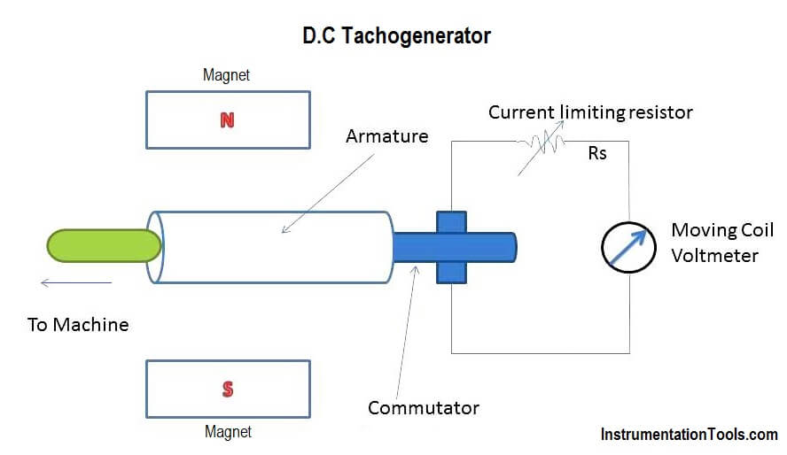

DC tachogenerator uses an armature that is attached to the object being measured. The armature rotates within a stationary magnetic field, and the induced voltage is proportional to shaft speed.
An AC tachogenerator does away with brushes and instead uses a stationary, wound stator and a rotor with permanent magnets.
- In this case, the rotating magnetic field of the rotor induces voltages in the 3-phase windings of the stator.
- The amplitude and frequency of the induced voltage are proportional to the speed of rotation.
- The AC output is rectified to a DC voltage whose amplitude is proportional to the speed of rotation, and the rectified output goes through a smoothing filter to reduce voltage ripples.
- Because AC current changes polarity twice per electrical cycle, an AC tacho generator cannot determine the direction of shaft rotation.
- But because they don’t require mechanical brushes, AC versions generally exhibit longer life and lower maintenance requirements then DC tacho generators.

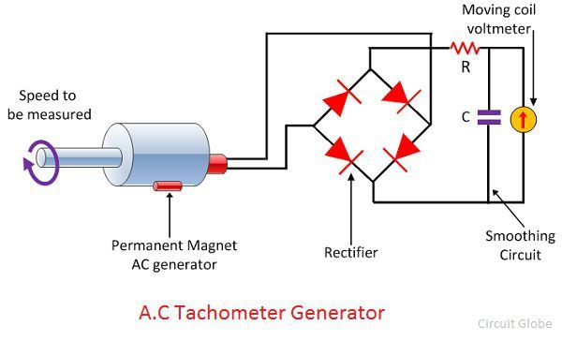

Application:-
In motion control applications, tacho generators are typically used with DC motors and drives to control motor speed.

Encoder

The encoder is an electromechanical device that can measure displacement. Encoders are normally digital displacement transducers, consisting of a mechanical element and a sensing head, typically of optical type.

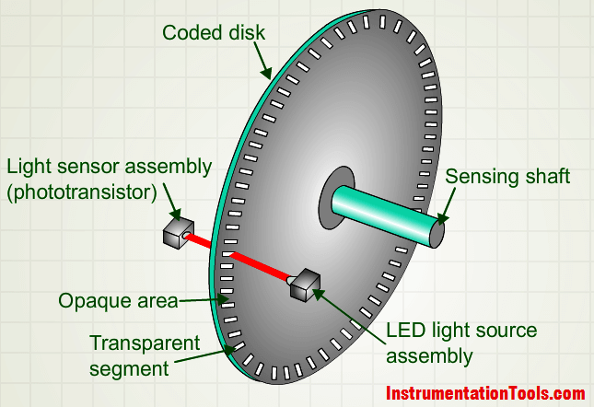

The mechanical element can be a disc (for rotary type encoders) or a ruler (for linear type encoders) with deposited or carved patterns. The sensing head includes a light source (LED) and a light sensor (photo detector) to read the generated code (the encoder output).

Working Principle:-
The Optical Encoders typically consist of a rotating and a stationary electronic circuit. The rotor is usually a metal, glass, or a plastic disc mounted on the encoder shaft. The disc has some kind of optical pattern, which is electronically decoded to generate position information.
The rotor disc in absolute optical encoder uses opaque and transparent segments arranged in a gray-code pattern. The stator has corresponding pairs of LEDs and photo-transistors arranged so that the LED light shines through the transparent sections of the rotor disc and received by photo-transistors on the other side. After the electronic signals are amplified and converted, they are then available for the evaluation of the position

Hall sensor

A Hall sensor works by using the Hall effect: when a current flows through a conductor in a magnetic field, the moving electrons are deflected sideways by the Lorentz force, creating a voltage (Hall voltage) across the conductor, perpendicular to both the current and the magnetic field. This voltage, which is proportional to the magnetic field's strength, allows the sensor to detect magnetic fields for applications like proximity sensing, speed measurement, and position sensing, outputting either an analog (proportional) or digital (on/off) signal.

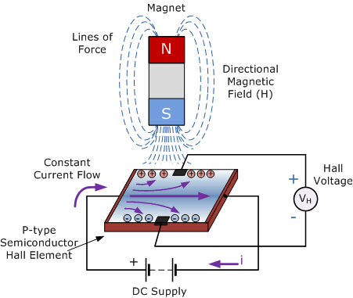

Working Principle
- A constant electrical current is passed through a thin semiconductor strip (the Hall element).
- When a magnet or magnetic field approaches the sensor, it exerts a force on the moving electrons.
- The Lorentz force pushes the electrons to one side of the semiconductor strip, causing a charge imbalance.
- This charge separation creates a measurable voltage (Hall voltage) across the sides of the strip.
- The magnitude of this Hall voltage is directly related to the strength of the magnetic field, allowing the sensor to detect its presence, strength, or changes, producing a useful electrical signal.

Distance sensor
A distance sensor is a reliable tool for a variety of applications for accurate as well as fast measurement, accurate positioning, and discovery of an extensive range of materials. The probable applications of this sensor mainly include examining the unwinding of coils, twofold sheet recognition otherwise the precise high bay stackers positioning.
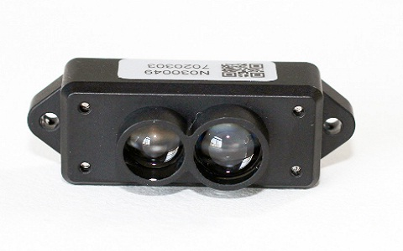distance-sensor Working Principle:-
Generally, these sensors work by generating some kind of waves like a laser, IR LED, and ultrasonic then it reads how it has altered once it gets back. This change mainly depends on the returned signal’s intensity, and the time it takes to return back, etc. The terms of distance sensor include resolution, range, and update rate.
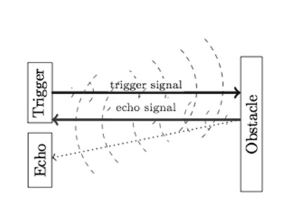distance-sensor-working
There is several things reason for deciding the option for best interfacing of a distance sensor project like a type of sensor, speed, power utilization, wire length from board to the sensor, etc.
light sensor
A light sensor is a device that is sensitive to light and can detect light and convert it into an electrical signal. It can measure the intensity, wavelength, frequency or direction of light.
working principle
- The light sensor working principle is based on the photoelectric effect. The sensor uses photosensitive materials that can respond to the presence of light.
- These materials can be semiconductors, photoconductive materials, or photovoltaic materials. When light hits the photosensitive material, its electrical properties change. This change can manifest as a variation in resistance, the generation of current, or a change in voltage. The sensor then converts this change into an electrical signal.
- The electrical signal generated by the light sensor is usually very weak and needs amplification. This is achieved through an internal amplifier within the sensor. The amplified signal can then be further processed to obtain useful information, such as light intensity or wavelength.
- The processed signal is then output in a form that can be read by other electronic components or systems. Depending on the application requirements, this output can be in the form of an analog signal (continuous signal) or a digital signal (discrete steps).

Measuring range of light sensor
For outdoor environments, the light intensity can reach 60,000 to 100,000 lux in direct sunlight in summer. 1,000 to 10,000 lux outdoors without the sun. 100 to 550 lux in bright summer indoors, 0.2 lux at night under a full moon.
For indoor environments, incandescent lamps can emit about 12.56 lux per watt, but the value varies with the size of the bulb. Small bulbs can emit more lumens, large bulbs less. The luminous efficiency of fluorescent lamps is 3 to 4 times that of incandescent lamp
Applications of light sensors
The role of the light sensor is to measure the intensity and change of the surrounding light and convert it into an electrical signal output to reflect the surrounding light conditions. It can be used in a variety of application scenarios to realize automatic control, lighting regulation, environmental monitoring and other functions.
The following are the main applications of light sensors:

Automatic lighting control: Automatically turn on indoor lighting and adjust the light intensity at night or on cloudy days. Automatically reduce or turn off indoor lighting during daytime or sunny seasons. During stage performances, control the color and direction of the lights on the stage to change as the performance progresses. All of these are inseparable from light sensors. Use the light sensor with other home automatic sensors (such as the temperature and humidity sensor) to create an automated living environment.
Weather monitoring: Light sensors are an important part of professional environmental weather stations. By installing light sensors on weather stations in remote areas, researchers can keep track of the light conditions at the monitoring points, such as sunny, cloudy or foggy days.
Temperature control systems: Light sensors can automatically adjust curtains, blinds or air-conditioning units according to the difference between indoor and outdoor light to provide a more comfortable living environment.
Agricultural production: Light sensors are components of greenhouse lighting systems. They monitor the amount of light in the greenhouse and control the timely opening or closing of the top sunshade to ensure that plants receive sufficient light to increase crop yields.
Industrial automation: Light sensors are often used to monitor the brightness and color of light sources to confirm the precise positioning and location of robots or assembly lines based on light perception. For example, in automated smart warehouses, light sensors can monitor light to ensure safety and clear visibility inside delivery vehicles.
Security systems: Light sensors can also be used in security systems such as fire alarm and intrusion detection. By monitoring changes in light, the sensor can detect abnormal events and trigger an alarm.

Accelerometer
- An electromechanical instrument for measuring acceleration forces is called the accelerometer.
- These forces could be stationary, like the constant pull of gravity, or dynamic, like in the case of many mobile gadgets, to detect motion or vibrations.
- Fundamentally speaking, acceleration is the change in velocity over a predetermined period of time. If we know the distance traveled and the time required, we may calculate the speed of a given body.
- However, the force enters the picture when calculating acceleration. Recently, a wide range of uses for accelerometers has emerged. Accelerometer Diagram

The below circuit diagram depicts the popular accelerometer in usage- ADXL335
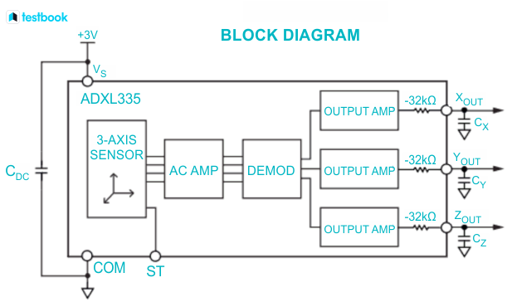

Working Principle
- An accelerometer’s main functional requirement is that it converts mechanical energy into electrical energy.
- When a mass that is actually like a spring is placed on the sensor, it starts to descend at that point.
- It has an acceleration since it is descending. This acceleration then transforms into a measurement of the electric signal, which is used to calculate the range in the position of the device.
- Both the simple structures and the programmed structural gadgets can both be found with an accelerometer. It comes in both analog and digital forms.
- Even while it appears to be a simple circuit for a bigger electronic device, it actually has many distinct sorts of parts, each of which has its own functions and operates in a variety of ways.
- The two most popular words would be the capacitance sensor in capacitors and the piezoelectric effect.
- The most prevalent type, known as the piezoelectric effect, uses microscopic crystal structures that are stressed by acceleration forces.
- These internal stresses cause the crystals to produce voltages, which are then interpreted by an accelerometer to measure the motion’s velocity and orientation.

Application of Accelerometer
The common uses of accelerometer are:
- Accelerometers that have a high sensitivity are utilized in inertial navigation systems.
- To recognise and keep an eye on rotating machinery vibrations.
- To have photographs shown on digital camera screens in an upright orientation.
- For drone flight stabilization.
- Accelerometers are used to measure acceleration, shock, vibration, and orientation.
- Used by laptops and mobile devices to determine the device’s location.
- Biaxial and triaxial acceleration at high frequencies are recorded in biological applications to distinguish between animal behavioral patterns.
- Checking the health of the equipment.
- To find rotator machine issues.
- These are also employed in structural and building monitoring to track the movement and vibration of the building under dynamic loads.
- To evaluate the depth of chest compressions during CPR.
- Accelerometer sensors are used by navigation systems to determine direction.
Force Sensor
- A Force Sensor is a sensor that helps in measuring the amount of force applied to an object. By observing the amount of change in the resistance values of force-sensing resistors, the applied force can be calculated.
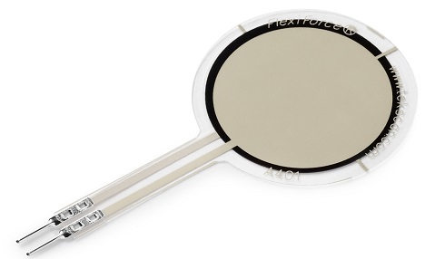Force-Sensor

Working Principle
- The general working principle of Force Sensors is that they respond to the applied force and convert the value into a measurable quantity.

- There are various types of Force Sensors available in the market based on various sensing elements.

- Most of the Force Sensors are designed using Force-Sensing Resistors. These sensors consist of a sensing film and electrodes.

- The working principle of a Force-sensing resistor is based on the property of ‘Contact Resistance’.
- Force-sensing resistors contain a conductive polymer film that changes its resistance in a predictable manner when force is applied on its surface.
- This film consists of, sub-micrometres sized, electrically conducting and non-conducting particles arranged in a matrix.
- When force is applied to the surface of this film, the microsized particle touches the sensor electrodes, changing the resistance of the film.
- The amount of change caused to the resistance values gives the measure of the amount of force applied.
- To improve the performance of the Force-Sensing resistors various efforts are being made with multiple different approaches such as, to minimize the drift of polymer various electrode configurations are being tested, testing with sensor by replacing the polymer with new materials such as carbon nanotubes, etc….

Applications of Force Sensor

- The main usage of the Force sensor is to measure the amount of force applied.
- There are various types and sizes of force sensors available for different types of applications.
- Some of the applications of Force sensor that uses force-sensing resistors includes pressure-sensing buttons, in musical instruments, as car-occupancy sensors, in artificial limbs, in foot-pronation systems, augmented reality,etc….

Examples of Force Sensors

- There are many types of force sensors available for different types of applications.

- Some of the examples of force sensors are Load cells, pneumatic load cells, Capacitive Load cells, Strain gauge load cells, hydraulic load cells, etc…

Torque sensor
- A torque sensor, also known as a torque transducer, torque meter, or torque gauge, is an essential instrument used to measure the torque or rotational force applied to various mechanical components.
- Torque sensors play a crucial role in evaluating the performance of rotating and non-rotating parts by converting mechanical torque into precise electrical signals.
- These sensors are widely utilized in industries such as automotive, aerospace, manufacturing, and research laboratories.

Working Principles of Torque Sensors

Torque sensors operate by detecting the strain or deformation experienced by a mechanical component when subjected to torque forces. The primary working principles include:
- Strain Gauge Technology:
  - Most commonly used in torque sensors.
  - Consists of strain-sensitive resistors attached to a rotating shaft, which experience deformation proportional to the applied torque.
  - Changes in electrical resistance are converted into an electrical signal that represents torque values.
- Magneto elastic Technology:
  - Utilizes the magnetoelastic properties of materials, where magnetic permeability changes under mechanical stress.
  - Offers high sensitivity and can be used in harsh environments.
- Optical Technology:
  - Uses laser-based or fiber optic systems to measure angular displacement and torque.
  - Provides high accuracy with minimal signal interference.
Applications of Torque Sensors

Torque sensors have a diverse range of applications across various industries, including but not limited to:
- Automotive Industry:
  - Measurement of engine and drivetrain performance.
  - Evaluation of torque output in electric and hybrid vehicles.
  - Testing of components such as power steering systems and braking mechanisms.
- Aerospace Sector:
  - Performance analysis of aircraft engines and turbines.
  - Monitoring of torque levels in control surfaces and landing gear mechanisms.
- Manufacturing and Industrial Machinery:
  - Monitoring of torque in conveyor systems, gearboxes, and robotic arms.
  - Ensuring optimal torque levels in assembly processes.
- Energy and Power Generation:
  - Performance assessment of wind turbines and hydroelectric generators.
  - Monitoring torque output in power transmission systems.
- Medical Equipment:
  - Used in prosthetics and robotic surgical instruments to ensure precise force control.
- Laboratory and Research Applications:
  - Development of viscosity measurement devices (e.g., viscometers).
  - Quality control testing in R&D departments.
- Process and Chemical Industries:
  - Monitoring torque in pumps, compressors, and mixing equipment.
  - Ensuring consistent material processing in pharmaceutical and food industries.
Tactile sensor
- A Tactile sensor is nothing but a touch sensor. It provides information about the object which has made contact with the sensor.
- The information can be in the form of the shape of the object, size of the object or even the type of the material.
- This sensor is sensitive to the touch, pressure or any force on its surface.
- This sensor is commonly sensing the above mentioned characteristics in the form of electrical parameters like capacitance or resistance.

Construction of a Tactile Sensor

- Tactile sensor consists of basic electronics components like capacitors, piezoresistors or optical light source and optical light detectors. Use of above mentioned components depends on the type of the sensor which is being used.
- These basic electronics components are used in large numbers to form one sensor. These basic electronic components are laid in the form of arrays like several rows and columns.
- Then an associated circuit is used in conjunction with these basic electronic components for further processing of the data which is captured by capacitor, piezoresistors or optical light source and optical light detector.

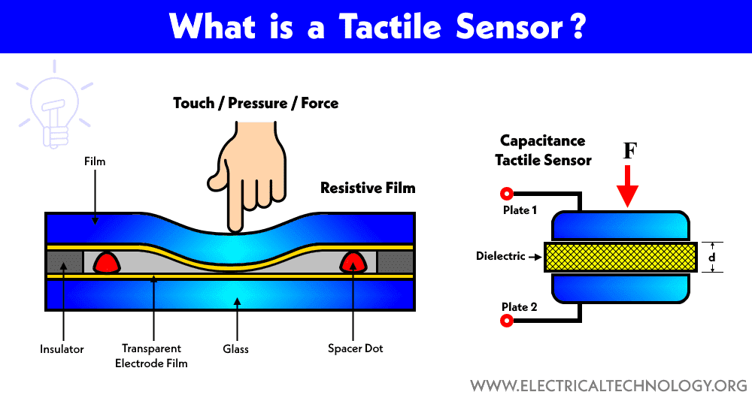
Working:-

- Tactile sensors work on the basic principles of electronics like capacitance change, resistivity change and change in intensity of light due to foreign body interference.
- The change in capacitance, resistance or light intensity is detected by the use of this sensor. Then this change is used to form a virtual image.
- The virtual image contains information like how much pressure is exerted from foreign body interference on all points it has made contact with the sensor, how is the shape of the foreign body, what is the size of the foreign body.
- fingerprint sensor can also be called a type of tactile sensor.
- Fingerprint sensor scans our finger which is a foreign body for this sensor. It then creates a virtual image by using the sensor and associated circuits in the mobile phone or a special purpose fingerprint sensor.
- For sensing the foreign body interference, an array or say multiple rows and columns containing the basic components is used.
- The foreign body makes contact with these components. Now after contact, there is change in electrical parameters which is input for the associated circuits.
- The associated circuits then create a virtual image as shown for a fingerprint sensor output. Creation of this kind of virtual image or getting data from the foreign body is the primary purpose of the sensor.

Applications

Tactile sensors are widely used in following areas:
- Mobile phones
- Capturing biometric data
- Pressure measurement
- Force measurement
- Home automation and security
- Automobile security
- Advanced medical devices
- Communication and research
- Modern robotics

Load cells

- Load cells are transducers that convert mechanical force—such as tension, compression, or torque—into measurable, calibrated electrical signals, making them the critical component in electronic weighing scales and force measurement systems.
- Most commonly using strain gauge technology, they are vital for industrial automation,, process control, and safety, with applications ranging from filling plants and silo monitoring to material testing.
Working Principle:
Most load cells use strain gauges arranged in a Wheatstone bridge configuration. When force is applied, the load cell's structure deforms, altering the resistance of the gauges and creating a proportional electrical signal.

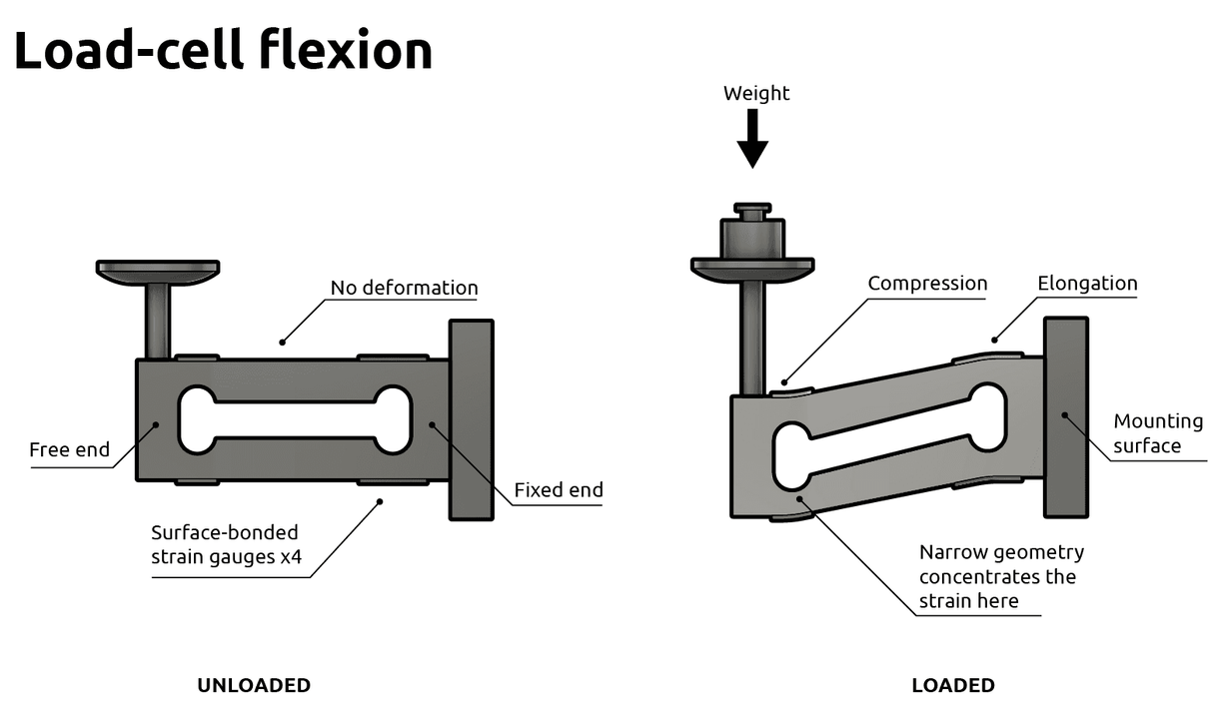
Applications:
Weighing: Platform scales, crane scales, truck scales, and laboratory balances.
Force Measurement: Monitoring stress in structures, monitoring presses in manufacturing, and material testing.
Piezoelectric transducer
- Piezoelectric transducer is an electrical transducer which can convert any form of physical quantity into an electrical signal, which can be used for measurement.
- An electrical transducer which uses properties of piezoelectric materials for conversion of physical quantities into electrical signals is known as a piezoelectric transducer.
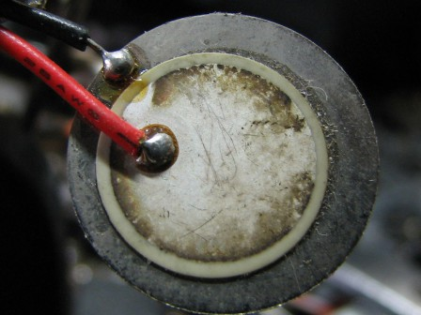Piezoelectric Transducer
- Piezoelectric materials exhibit the property of piezoelectricity, according to which on the application of any type of mechanical stress or strain leads to the generation of an electric voltage proportional to the applied stress.
- This produced electric voltage can be measured using voltage measuring instruments to calculate the value of stress or strain applied to the material.

Working:
- Piezoelectric Transducer works with the principle of piezoelectricity. The faces of piezoelectric material, usual quartz, is coated with a thin layer of conducting material such as silver.
- When stress has applied the ions in the material move towards one of the conducting surface while moving away from the other.
- This results in the generation of charge. This charge is used for calibration of stress.
- The polarity of the produced charge depends upon the direction of the applied stress. Stress can be applied in two forms as Compressive stress and Tensile stress as shown below.
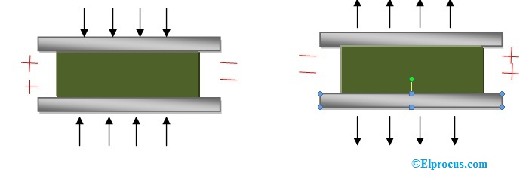Working of a Piezoelectric Transducer

Piezoelectric Transducer Formula
The orientation of the crystal also effects the amount of voltage generated. Crystal in a transducer can be arranged in longitudinal position or transverse position.
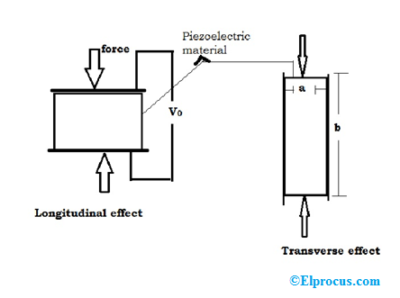Piezoelectric Transducer Formula
Longitudinal and Transverse Effect
In the longitudinal effect, the charge generated is given by
Q = F * d
Where F is the applied force,d is the piezoelectric coefficient of the crystal.
Piezoelectric coefficient d of quartz crystal is around 2.3 * 10⁻¹² C/N.
In the transverse effect, the charge generated is given by
Q = F * d * (b/a)
When the ratio b/a is greater than 1 the charge produced by transverse arrangement will be greater than the amount generated by longitudinal arrangement.

Piezoelectric Transducer Circuit
The working of a basic piezoelectric transducer can be explained by the below figure.
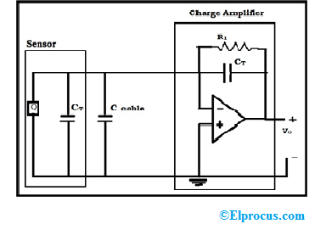Piezoelectric Transducer Circuit
Here quartz crystal coated with silver is used as a sensor to generate a voltage when stress is applied on it. A charge amplifier is used to measure the produced charge without dissipation. To draw very low current the resistance R1 is very high. The capacitance of the lead wire that connects the transducer and piezoelectric sensor also affects the calibration. So the charge amplifier is usually placed very near to the sensor.
So in a piezoelectric transducer when mechanical stress is applied a proportional electric voltage is generated which is amplified using charge amplifier and used for calibration of applied stress.

Applications
- As piezoelectric materials cannot measure static values these are primarily used for measuring surface roughness, in accelerometers and as a vibration pickup.
- They are used in seismographs to measure vibrations in rockets.
- In strain gauges to measure force, stress, vibrations etc…
- Used by automotive industries to measure detonations in engines.
- These are used in ultrasonic imaging in medical applications.

Advantages and Limitations of Piezoelectric Transducers
The advantages and limitations of piezoelectric transducers include the following.
Advantages
- These are active transducer i.e. they don’t require external power for working and are therefore self-generating.
- The high-frequency response of these transducers makes a good choice for various applications.
Limitations
- Temperature and environmental conditions can affect the behavior of the transducer.
- They can only measure changing pressure hence they are useless while measuring static parameters.
piezoresistive sensor

A piezoresistive sensor detects pressure, force, or strain by exploiting the piezoresistive effect, where a material's electrical resistance changes when mechanically deformed, commonly using silicon diaphragms with integrated resistors in a Wheatstone bridge for precise measurement.

Working:-
- A diaphragm (often silicon) bends or deforms when subjected to pressure or force.
- This deformation stretches or compresses piezoresistive resistors (strain gauges) embedded in the diaphragm, altering their electrical resistance.
- These resistors are typically arranged in a Wheatstone bridge circuit, which amplifies the small resistance change into a measurable voltage output proportional to the applied force or pressure.

Applications
- Pressure Sensors: Automotive (tire pressure), aerospace, industrial control.
- Force Sensors: Load cells, tactile sensing in robotics.
- Accelerometers: Inertial navigation, shock detection.
- Medical Devices: Monitoring physiological pressures.

variable capacitive type sensor
A variable capacitive type sensor is a transducer that converts physical mechanical movement—such as displacement, pressure, or liquid level—into an electrical signal by altering its capacitance. It works by changing the distance between plates, the overlapping area of plates, or the dielectric constant between them, offering high sensitivity for both static and dynamic measurements.
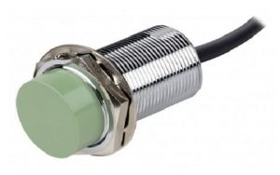

Operating Principles
This sensor includes a high-frequency oscillator with a sensing surface that is formed through two metal electrodes. Once an object approaches close to the sensing surface, then it moves into the electrostatic field of the electrodes & changes the oscillator’s capacitance.
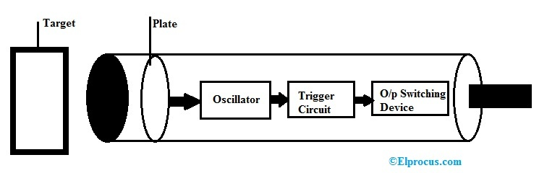

- Consequently, the oscillator circuit will begin to oscillate & change the sensor’s output condition once it arrives at a certain amplitude.
- Once the target goes away from the capacitive sensor, the amplitude of the oscillator will reduce, switching the capacitive sensor back to its original position.
- This sensor’s typical detecting range is about 1 inch or 25 mm whereas some sensors’ range is extended up to 2 inches.
- These sensors detect the superior dielectric constant of an object simply.
- So, this makes achievable the detection of the material within nonmetallic containers because the dielectric constant of liquid is much higher as compared to the container.
- So this provides the sensor ability to observe throughout the container & detect the liquid. For better operation, they must utilize in a situation with a quite constant temperature & humidity.
- The capacitive sensor is one kind of device used for capacitive sensing. It is mainly based on the capacitive coupling principle.
- This sensor can simply detect & measure different things like motion, chemical composition, displacement, electric field & indirectly detect many other variables which can be changed into dielectric constant or motion like acceleration, pressure, fluid composition & fluid level.
- A capacitance sensor includes two metal plates which are separated by a distance ‘d’ and area ‘A’. So the capacitance ‘C’ between two terminals can be given through the following expression.
C = ε0*εr*A/h

Where,
‘C’ is capacitance within Faradays
‘εr’ is Insulator’s relative dielectric constant
‘εo’ is dielectric constant for free space
‘A’ is the overlapping area of two plates
‘h’ is the width of the gap between two plates.

variable reluctance (VR) sensor
A variable reluctance (VR) sensor operates by converting mechanical motion (usually rotational speed or position) into an electrical signal by detecting changes in magnetic flux. A permanent magnet inside the sensor creates a magnetic field, and as a nearby ferrous, toothed gear passes, the air gap changes, altering the magnetic reluctance (resistance to flux). This fluctuating magnetic flux induces an AC voltage in the sensor coil, with frequency proportional to speed.

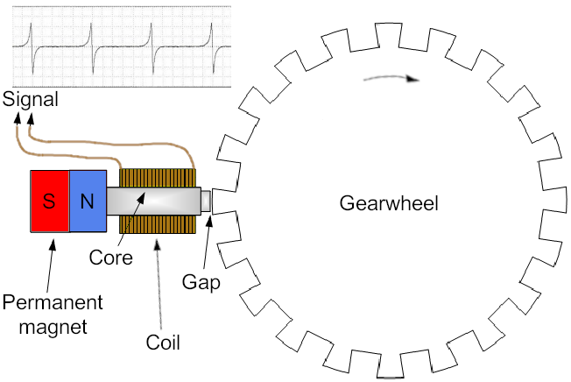

Working Principles:
- The sensor consists of a permanent magnet, a ferromagnetic core, and a surrounding coil of wire.
- When a gear tooth is near the sensor tip, the reluctance is low, causing high magnetic flux through the core. As the tooth moves away, the air gap increases, increasing the reluctance and decreasing the flux.
- According to Faraday’s Law, the continuously changing magnetic flux (dΦ/dt) induces a time-varying AC voltage in the coil.
- The frequency of this AC signal corresponds to the speed of the rotating gear. The amplitude is dependent on the target's size, speed, and distance.

Applications:
- Commonly used for speed measurement in automotive, ABS braking, and industrial machinery.
Synchros
Synchro has a single winding rotor that rotates inside a stator of three windings, much like an electric motor as shown in Figure 1. The primary winding wound around the rotor is excited by an alternating current, which induces currents to flow in three Y-connected secondary windings (oriented 120° apart).
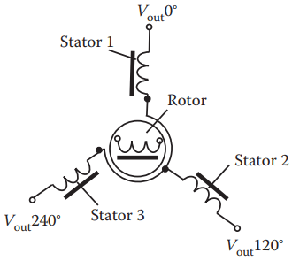
The relative magnitudes of secondary currents are measured to determine the angle of the rotor relative to the stator, or the currents can be used to directly drive a receiver synchro that will rotate in unison with the synchro transmitter. In the latter case, the whole system is often called a selsyn (a portmanteau of self and synchronizing).
A synchro provides accurate angular and rotational information. Since synchros have three stator coils in a 120° orientation, they are more difficult than resolvers to manufacture and are therefore more costly. Today, synchros find decreasing use, except in certain military and avionic retrofit applications.

Working Principle
A synchro is essentially a variable coupling transformer that uses the principle of electromagnetic induction. The magnitude of the magnetic coupling between the primary and secondary windings varies according to the position of the rotating element.
Traditionally, the simplest synchro system contains two parts: synchro transmitter and synchro receiver. The synchro transmitter consists of a singlephase, salient-pole (dumbbell-shaped) rotor and three-phase Y-connected stator.
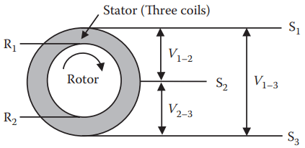Figure 2
As shown in Figure 2, the primary coil (usually driven at 400 Hz) is the rotor and has two terminals (R₁ and R₂). The stator functions as the secondary coil and has three terminals (S₁, S₂, and S₃). There are three stator coils in a 120° orientation and they are electrically Y-connected.
When a synchro emitter is driven by an AC current, the stator has three output voltages V_{1–2}, V_{2–3}, and V_{1–3}. The transmitter equations show that nowhere over the entire 360° rotation of the rotor has the same set of voltages produced. Therefore, each set of voltage output (V_{1–2}, V_{2–3}, and V_{1–3}) corresponds to a unique rotor position.
A receiver can take the three outputs V_{1–2}, V_{2–3}, and V_{1–3} from the emitter and transfer these three voltages into an angular position. Sometimes a receiver has its own rotor that rotates when receiving the three outputs from the emitter (V_{1–2}, V_{2–3}, V_{1–3}).
The term “synchro” is an abbreviation of the word “synchronous,” which came from the fact that the receiver’s rotor rotates synchronously with the emitter’s rotor. Today, most synchros only contain a rotor (or emitter), and they rely on other means to determine the rotor’s position based on three voltage outputs.

Resolver Working Principle
Resolver has a single-winding rotor that rotates inside a stator of two windings and provides accurate angular and rotational information.
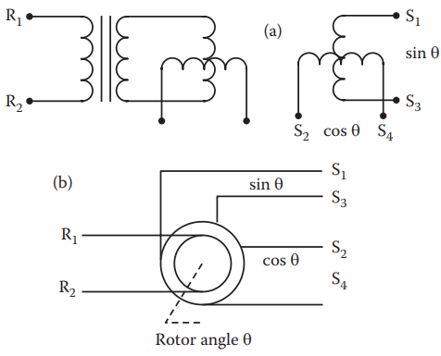Figure 5
A resolver is basically a rotating transformer with one primary winding and two secondary windings that are phased 90° (see Figure 5a). As the rotor turns, the amplitude of the secondary voltage changes, modulating the input carrier. This establishes two separate outputs having a sine/cosine relationship.
As shown in Figure 5b, it accepts an AC excitation through terminals R₁ and R₂ at the rotor and produces a pair of two-wire outputs: sin θ (between terminals S₁ and S₃) and cos θ (between terminals S₂ and S₄), where θ is the angular position of the rotor. The position of the rotor can then be calculated by
θ = arctan(sin θ/cos θ)
Synchros are more difficult than resolvers to manufacture and are therefore more costly. Today, synchros find decreasing use, except in certain military and avionic retrofit applications.
The main parameters of resolvers are as follows:
Input voltage: 1 – 26 V. Larger voltage can cause the saturation of a resolver’s magnetic structure, resulting in increased error and null voltage.

Frequency: 400–5000 Hz frequency. Lower frequency can result in the saturation of a resolver’s magnetic structure, increase errors, and change some other parameters. Higher frequencies may result in increased magnetic flux leakage as well as changes in capacitance coupling.

Voltage sensitivity or voltage gradient: defined by the output voltage per one degree (1°) rotor rotating angle.

Transformation ratio (TR): defined as the ratio of output voltage to input voltage when the output is at maximum coupling, that is

TR = Max{V_{out}}/V_{in}

TR is approximately proportional to the ratio of effective turns, secondary N₂ to primary N₁:

TR = (KN₂)/N₁

Where K is a constant.
A higher TR is easy to achieve in one-speed resolvers. However, it is more difficult to achieve in multispeed resolvers because of increased flux leakage and increased N₂ using very fine magnetic wire that complicates the manufacturing process.

Phase shift: the difference between the time phase of the primary and secondary voltage when the output is at maximum coupling.

Null voltage: the residual voltage at the point of minimum magnetic coupling between the primary and secondary windings. It is measured when the “in-phase” secondary voltage is zero.

Number of speeds: the number of amplitude-modulated sinusoidal cycles in one revolution of the resolver. Multiple-speed resolvers are achieved by increasing the number of magnetic poles in the rotor and stator equally. Increasing the number of speeds can increase the accuracy, but it is limited to the size of the resolver.

A single-speed resolver is essentially a single-turn absolute device. By increasing the speeds of a resolver, the absolute information is lost. If space permits, mounting a single-speed resolver on top of a multiple-speed resolver will provide higher accuracy and absolute information.

Applications of Synchros and Resolvers
Synchros and resolvers offer extremely high accuracy and fast measurement, and are used in industrial metrology, radar antennae, and telescopes.
Synchros are found in just about every weapon system, communication system, underwater detection system, and navigation systems. They are reliable, adaptable, and compact.
Resolvers lend themselves to maximum applications because of their simple and standard components similarity to electric motors (windings, laminations, and bearings). The most popular use of resolvers is in permanent magnet brushless AC servo motors, military, and aerospace applications.

